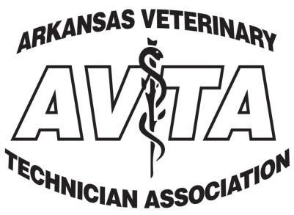
Membership Application
Name: |  |  | DOB: | Phone:
Address: |  |  | City: | State:
Zip Code: | Email Address: |  |  | Date:
Employer: |  | Address: |  | City:
State: |  | Zip Code: |  | Phone:
Are you a graduate of a AVMA accredited program? □Yes □No □Enrolled |  | College:  Year Graduated: |  | License #:
Members will receive an electronic quarterly newsletter, invitations to exclusive member events and discounts on continuing education meeting registration. Please provide an email address above.
Active Membership | Any CVT,RVT or LVT. Must be certified and/or have a diploma from an AVMA Accrediated  Program. Full voting rights are granted. | $20.00
Associate Membership | Any individual interested in supporting or promoting the AVTA. This includes DVMs, pharmaceutical representatives, veterinary assistants, receptionists, caretakers and managers. Non-voting rights. | $15.00
Institutional Membership | Any facility interested in supporting the AVTA such as veterinary practices, diagnostic laboratories, universities or research facilities. Non-voting rights. | $20.00
Student Membership | Any student currently enrolled in a veterinary technology program. | FREE
Please make all checks to AVTA & mail completed forms to:
AVTA
P.O. Box 1038
Morrilton, Ar 72110

